Lab2
Task1 redis
After creating docker-compose.yaml file and run docker-compose up
1 creating node1 on right terminal and node2 on left terminal
2 set key in node1 to be consistencycheck and ask node 2 to get key
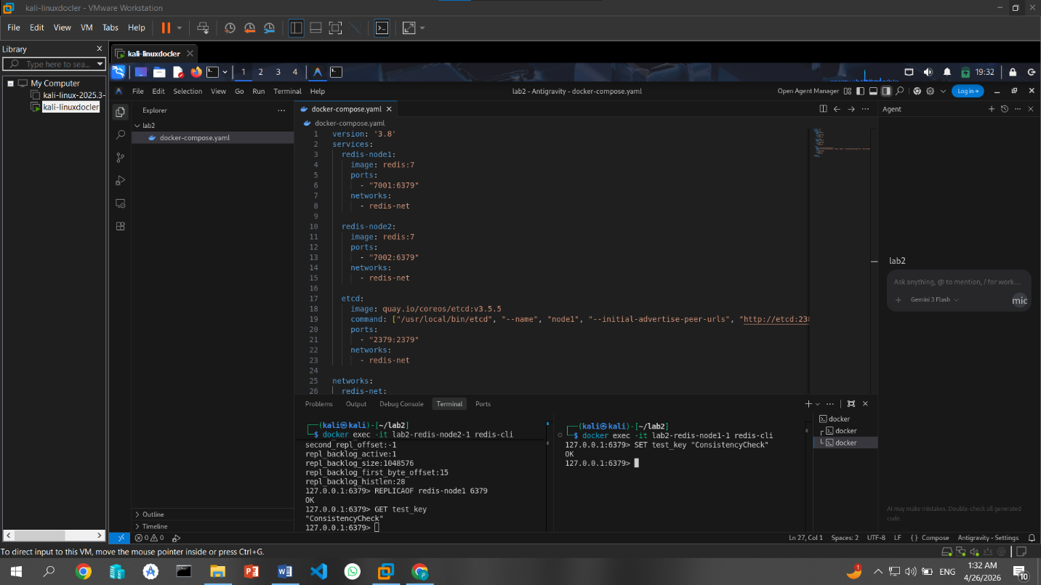
Result node 2 replied with consistencycheck which implies it was able to read from node 1
3 use stop lab2-redis-node2-1 to stop node2 from working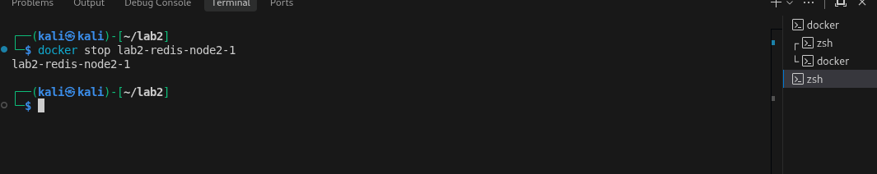

4 set partition key to stillworking and then re activate node2
At first it doesn’t return stillworking because of partition but after short amount of time it reads key again and show partition key -> stillworking
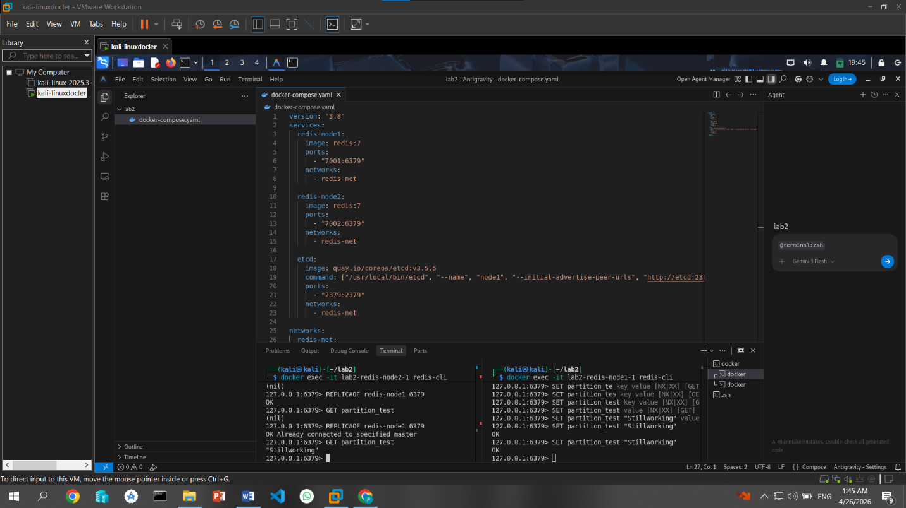
Task2 raft
I created etcd-1
I made it show status of endpoint
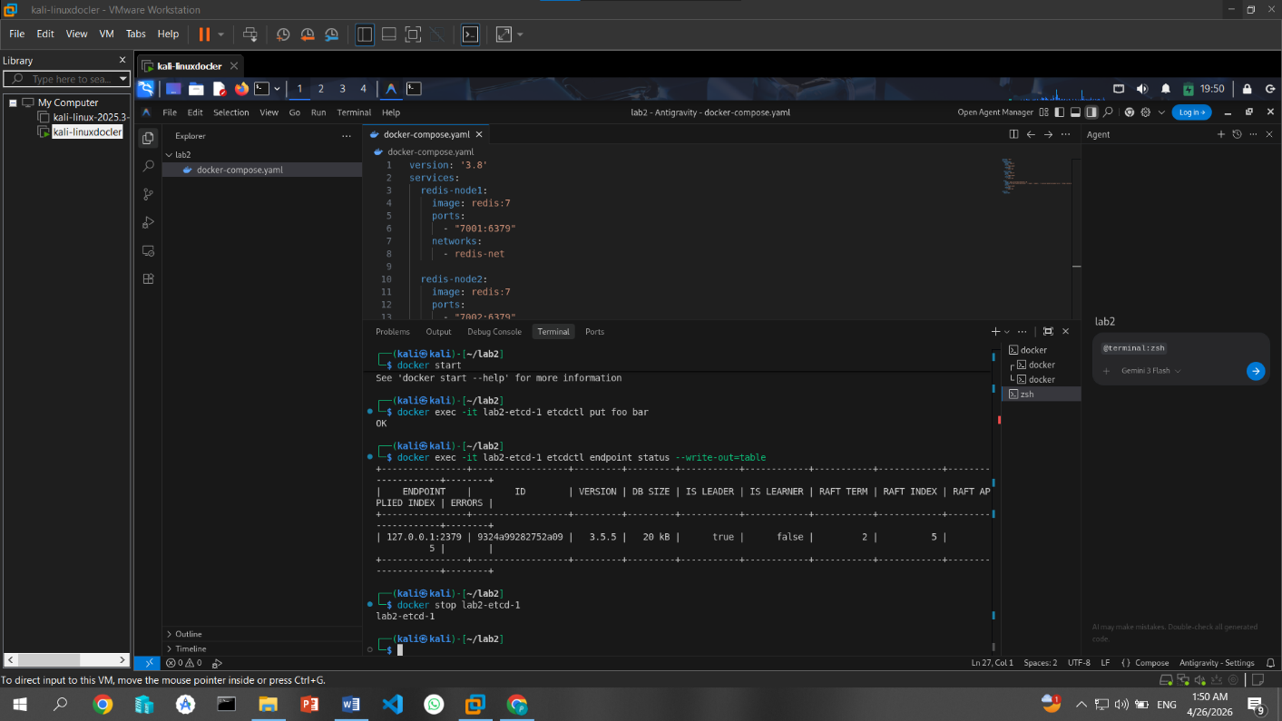
And shut down etcd-1

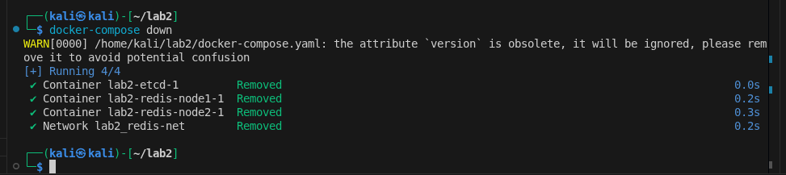
And then I used docker-compose down to close all containers

